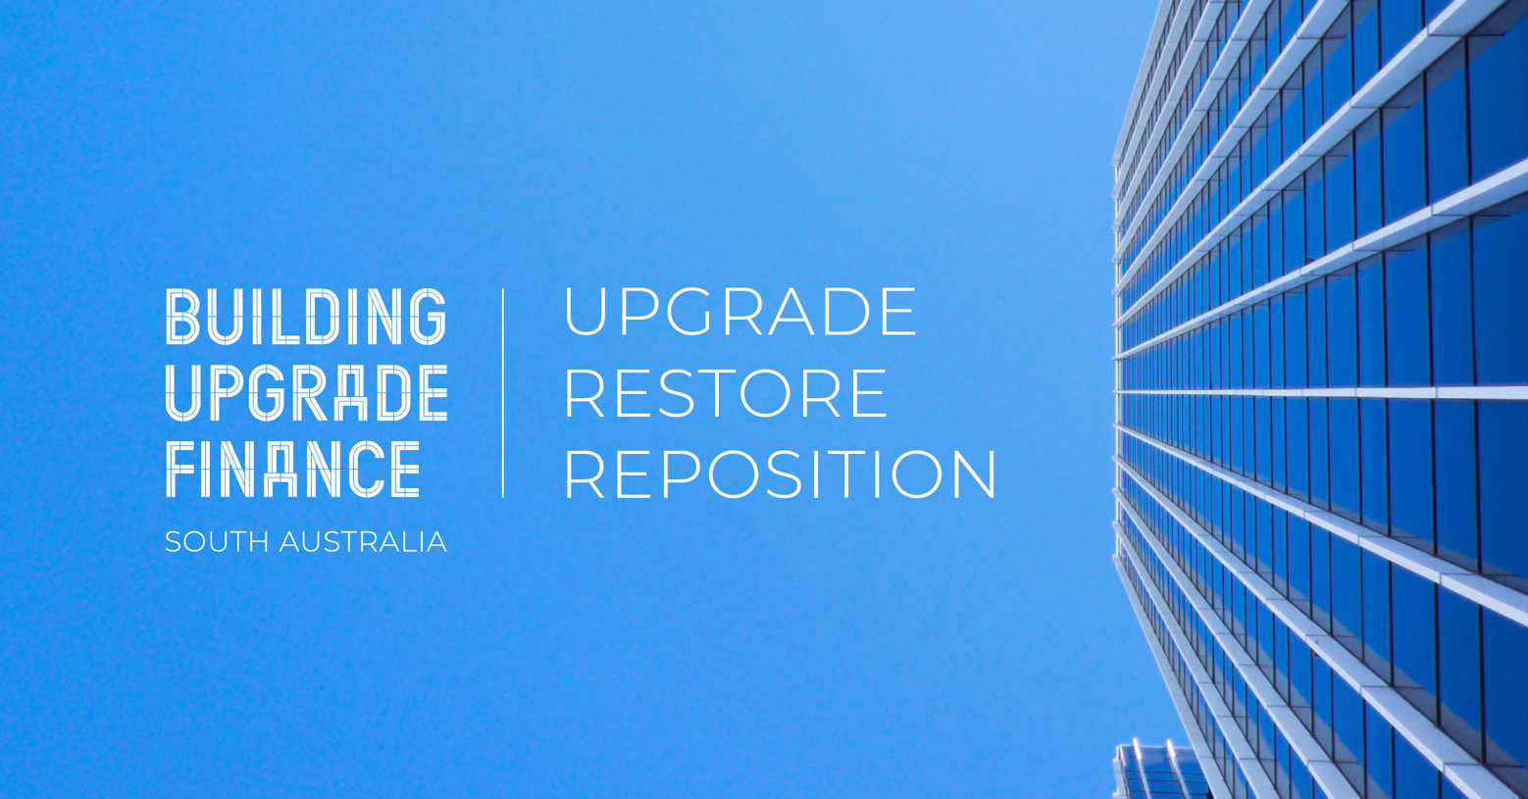
Example External E-News Feature
The City of XX is thrilled to announce our participation in Building Upgrade Finance, enabling our community to access long term competitive finance to achieve environmental upgrades to non-residential buildings and a broader scope of upgrades to non-residential heritage listed buildings.
Building owners may enjoy a series of benefits including the ability to save on energy costs, increase asset value and improve overall cash flow.
Discover your asset’s potential or how you can leverage Building Upgrade Finance – visit buildingupgradefinance.net.au for more information.

