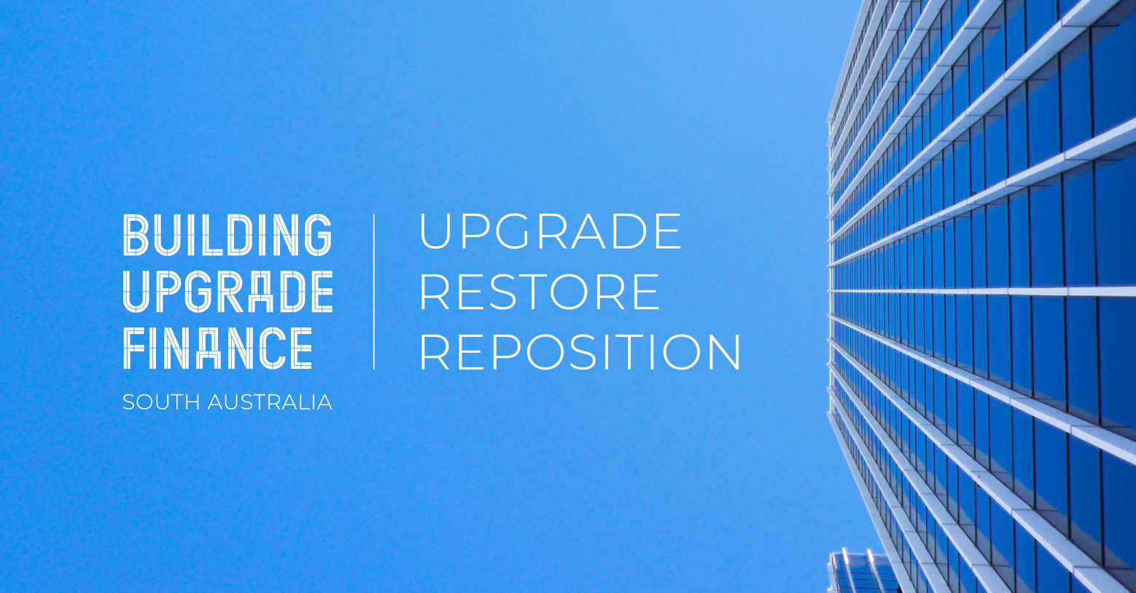
Example Website Feature
Building Upgrade Finance is a unique finance product that is available in the City of XX to assist building owners with environmental upgrades to non-residential buildings as well as restoration and upgrades to non-residential heritage buildings. It is provided by private sector finance providers and enabled by the council.
Building Upgrade Finance is available for a wide range of environmental upgrades including solar photovoltaic panels, water and energy efficiency fittings, wastewater reuse systems, waste management systems and much more.
Owners of non-residential State and local heritage listed buildings can also access Building Upgrade Finance for conservation works, access or building compliance improvements and works to allow ongoing use of the building.
The loan structure involves three parties entering into a Building Upgrade Agreement, where a:
- Building owner seeks finance for a building upgrade
- Finance provider lends finance for a building upgrade
- Council collects repayments from the building owner and transfers them to the finance provider.
This structure provides the security for the loan and enables unique benefits that differ from other finance solutions.
What are the key benefits?
- No additional security is needed
- Longer-term finance (e.g. 10-20 years)
- Competitive fixed interest rates
- No deposit – 100% project finance is available
- Ability to share costs with tenants
- Ability to transfer outstanding loan repayments to a new owner if agreed.
What does the process involve?
- Identify upgrade opportunities for your building.
- Discuss Building Upgrade Finance eligibility with the Building Upgrade Finance Central Facilitator, a finance provider or your council contact.
- Confirm finance and council application approval.
- Contract signed, funds released and upgrade work undertaken!
For further information please visit buildingupgradefinance.net.au or contact the Building Upgrade Finance Central Facilitator for South Australia, Lara Daddow: l.daddow@cityofadelaide.com.au or (08) 8203 7884.
<Optional>The City of XX contact in relation to Building Upgrade Finance is XXXXXXX.

